Summer 2013 Mr. McGowan
AP Calculus AB Minuteman Tech
Quiz 15 – Integration by Parts

Integrate using a u-substitution:
1) 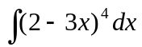= 2) 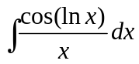=

Use Integration by parts to integrate:
3) 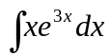= 4) 

